KPI’s

Total Revenue

SELECT SUM(total_price) AS Total_Revenue from pizza_sales;

Average Order Value

SELECT SUM(total_price) / COUNT(DISTINCT order_id) AS Avg_Order_Value from pizza_sales;

Total Pizza Sold

SELECT SUM(quantity) AS Total_Pizza_Sold from pizza_sales;

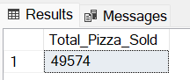

Total Order Placed

SELECT COUNT(DISTINCT order_id) AS Total_Orders from pizza_sales;

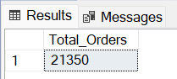

Average Pizza per order

SELECT CAST( CAST(SUM(quantity) AS decimal(10,2)) /

CAST(COUNT(DISTINCT order_id) AS decimal(10,2)) AS decimal(10,2)) AS Average_Pizza_per_order

from pizza_sales;

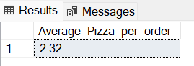

CHART REQUIREMENTS

DAILY TREND FOR TOTAL ORDERS

select DATENAME(DW, order_date) AS order_day, COUNT(DISTINCT order_id) AS Total_orders from pizza_sales

GROUP BY DATENAME(DW, order_date)

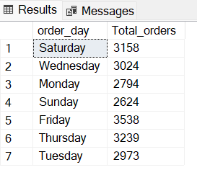

MONTHLY TREND FOR TOTAL ORDERS

select DATENAME(MONTH, order_date) AS Month_name, COUNT(DISTINCT order_id) AS Total_orders from pizza_sales

GROUP BY DATENAME(MONTH, order_date)

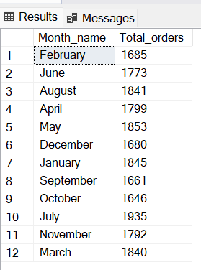

PERCENTAGE SALES BY CATEGORY

select pizza_category, SUM(total_price) * 100 / (select SUM(total_price) from pizza_sales) AS percentage_sales from pizza_sales

group by pizza_category

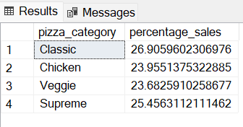

PERCENTAGE SALES BY SIZE

select pizza_size, SUM(total_price) * 100 / (select SUM(total_price) from pizza_sales) AS percentage_sales from pizza_sales

group by pizza_size

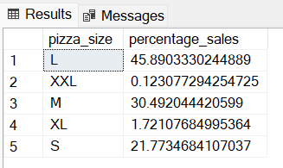

TOP 5 PIZZA NAME BY REVENUE

select TOP 5 pizza_name, SUM(total_price) as Total_Revenue from pizza_sales

group by pizza_name

order by Total_Revenue desc

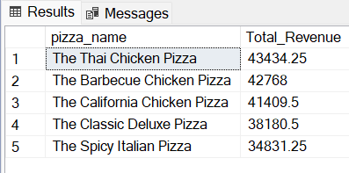

TOP 5 PIZZA NAME BY QUANTITY

select TOP 5 pizza_name, SUM(quantity) as Total_quantity from pizza_sales

group by pizza_name

order by Total_quantity desc

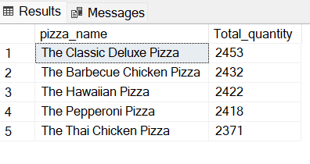

TOP 5 PIZZA NAME BY TOTAL ORDERS

select TOP 5 pizza_name, COUNT(distinct order_id) as Total_orders from pizza_sales

group by pizza_name

order by Total_orders desc

